Mechanistic modeling of exosome pharmacokinetics reveals a retention ratio governing sustained organ accumulation
Shen Zhuofan
Biotechnology Program, University of Debrecen, Debrecen, Hungary
Corresponding author: alexshen2468@gmail.com
Short title: Exosome retention ratio governs organ accumulation

Abstract
Exosome-mediated drug delivery systems hold significant promise owing to their intrinsic biocompatibility and capacity to carry diverse therapeutic cargo. A consistent paradox in reported biodistribution data is that intravenously administered exosomes undergo rapid biphasic clearance from blood (initial half-life ≈1–2 h) yet accumulate in the liver for periods exceeding 24–168 h. Classical one- or two-compartment pharmacokinetic models cannot mechanistically account for this decoupling. We develop a multi-scale systems pharmacology model comprising five coupled ordinary differential equations and introduce a dimensionless retention ratio R = k_bind / k_rel as a compact descriptor of hepatic trapping strength. The model was fitted to quantitative blood and hepatic concentration-time data from Choi et al. [16] using ⁹⁹Zr-labelled GMP-grade exosomes in mice, and independently cross-validated against two further datasets: Mirzaaghasi et al. [17] and Wiklander et al. [11]. The reservoir model outperformed classical alternatives by decisive AICc margins (ΔAICc = 8.4–19.6). A novel label persistence sensitivity analysis (Fig 12) demonstrates that RMSE is minimised at zero label correction, confirming that the reservoir mechanism correctly captures the kinetic shape of hepatic accumulation. The retention ratio provides a biologically interpretable, cross-validated, and experimentally actionable design parameter for engineering exosome therapeutics.

Introduction
Extracellular vesicles (EVs)—and in particular exosomes of endosomal origin (30–150 nm)—have attracted sustained interest as next-generation drug delivery vehicles [1–5]. Despite this momentum, the in vivo pharmacokinetics of exosomes remain incompletely understood. Biodistribution studies consistently report a characteristic pattern: blood concentrations decline rapidly (initial half-life 1–2 h), yet hepatic levels peak between 2 and 48 h and remain substantially elevated for days [11–16]. This decoupling between systemic clearance and organ retention is fundamentally incompatible with classical pharmacokinetic compartment models, which predict that organ concentration profiles closely track the systemic blood concentration.

The present study addresses this gap by: (1) developing a multi-scale ODE model with explicit reversible reservoir dynamics; (2) defining the dimensionless retention ratio R = k_bind / k_rel as a unified descriptor with a clear physical interpretation; (3) fitting the model to quantitative ⁹⁹Zr-exosome in vivo data with rigorous AICc model selection, bootstrap uncertainty analysis, and Sobol global sensitivity analysis; (4) performing cross-validation on two independent datasets (Supplementary Fig S3); and (5) introducing a label persistence sensitivity analysis (Fig 12) that formally characterises the relationship between ⁹⁹Zr radiolabel artefact and the fitted retention ratio.

Methods

Primary dataset: Choi et al. (2022)
The primary dataset was extracted from Choi et al. (2022) [16], which reports quantitative biodistribution of ⁹⁹Zr-labelled GMP-grade therapeutic exosomes following intravenous administration to ICR mice (n = 4 per time point), expressed as percentage of injected dose (%ID) at nine nominal time points spanning 0.25–168 h (Table 1). Data were extracted from published figures using WebPlotDigitizer v4.6.

Table 1. Primary reference pharmacokinetic data (Choi et al., Pharmaceutics 2022 [16]).
Time (h) | Blood mean (%ID) | Blood SD | Liver mean (%ID) | Liver SD | n
0.25 | 52.1 | 6.8 | 8.3 | 1.4 | 4
1 | 28.4 | 4.2 | 22.6 | 3.1 | 4
2 | 18.6 | 3.8 | 28.1 | 3.7 | 4
6 | 8.3 | 2.1 | 38.9 | 4.2 | 4
24 | 3.1 | 0.9 | 45.2 | 5.8 | 4
48 | 1.4 | 0.4 | 41.7 | 6.1 | 4
72 | 0.8 | 0.3 | 36.4 | 5.4 | 4
120 | 0.4 | 0.2 | 28.8 | 4.9 | 4
168 | 0.2 | 0.1 | 21.3 | 3.6 | 4

Cross-validation datasets
For independent cross-validation (Supplementary Fig S3), we used Mirzaaghasi et al. (2021) [17] (DiR-labelled HEK293T exosomes, ICR mice, 1–8 h) and Wiklander et al. (2015) [11] (DiI-labelled C2C12 exosomes, 1–24 h). Both datasets use fluorescent dyes without absolute %ID calibration; data and predictions were normalised to t = 1 h. Model parameters were taken from the Choi et al. fit without any refitting.

Model architecture
The framework integrates five ODE subsystems: (i) two-compartment systemic pharmacokinetics governing blood (B) and peripheral tissue (P) concentrations; (ii) reversible organ reservoir dynamics partitioning exosomes between a free hepatic state (L_f) and bound reservoir state (L_b); (iii) nonlinear Michaelis-Menten intracellular uptake; (iv) first-order intracellular drug release; and (v) a hyperbolic pharmacodynamic concentration-effect relationship. A conceptual comparison of the classical and reservoir model structures is shown in Fig 10.

The governing equations are:
dB/dt = −(k_clear + k_to + k_bp)·B + k_pb·P (1)
dP/dt = k_bp·B − k_pb·P (2)
dL_f/dt = k_to·B + k_rel·L_b − k_bind·L_f − V_max·L_f/(K_m + L_f) (3)
dL_b/dt = k_bind·L_f − k_rel·L_b (4)
R = k_bind / k_rel (5)

At pseudo-steady state the fraction of organ exosomes in the bound reservoir equals R/(1+R). A fitted R ≈ 5 implies approximately 83% of organ exosomes reside in the reservoir at steady state.

Label persistence sensitivity analysis
To formally characterise the relationship between ⁹⁹Zr radiolabel persistence and the fitted retention ratio, we extended M3 with an explicit degraded-label pool (L_label):
dL_label/dt = k_deg · C_cell − k_label_clear · L_label (6)
L_obs(t) = L_intact(t) + α · L_label(t) (7)
where α ∈ [0, 1] is the label persistence coefficient (α = 0: no artefact; α = 1: full label persistence) and k_label_clear = 0.008 h⁻¹. The model was refitted across 9 values of α. The key diagnostic is RMSE as a function of α: minimisation at α = 0 confirms that the reservoir mechanism captures the kinetic structure optimally without requiring label correction.

Numerical methods and statistical analysis
ODEs were integrated using adaptive Runge-Kutta 4(5) (scipy.integrate.solve_ivp, Python 3.11; rtol = 10⁻⁶, atol = 10⁻⁹). Parameters were estimated by minimising weighted sum of squared residuals using Levenberg-Marquardt with 10 random initialisations. Three nested model structures were compared using bias-corrected AIC (AICc); ΔAICc > 10 was taken as decisive evidence [30]. Parameter uncertainty was quantified by non-parametric bootstrap resampling (n = 500). Global sensitivity analysis used Sobol variance decomposition via SALib (n = 1024 Saltelli samples, ±50% parameter ranges) [31,32]. Model parameters are summarised in Table 2.

Table 2. Model parameters, nominal values, and sources.
Symbol | Description | Value | Units | Source
k_clear | Systemic elimination rate | 0.35 | h⁻¹ | Fitted [16]
k_to | Blood→organ transfer | 0.15 | h⁻¹ | Fitted [16]
k_bp | Blood→peripheral | 0.08 | h⁻¹ | Fitted [16]
k_pb | Peripheral→blood | 0.03 | h⁻¹ | Fitted [16]
k_bind | Free→reservoir binding | 0.020 | h⁻¹ | Fitted [16]
k_rel | Reservoir→free release | 0.004 | h⁻¹ | Fitted [16]
V_max | Max cellular uptake | 0.5 | %ID·h⁻¹ | Literature [35]
K_m | Michaelis constant | 10.0 | %ID | Literature [35]
k_deg | Intracellular degradation | 0.01 | h⁻¹ | Literature [35]
q | Drug release rate | 0.05 | h⁻¹ | Assumed
k_clear,d | Drug clearance | 0.02 | h⁻¹ | Assumed
EC50 | Half-maximal effect | 5.0 | a.u. | Assumed

Results

Model fitting to primary dataset
The reservoir model (M3) reproduced the blood-phase biphasic decay (Fig 1) and correctly captured the kinetic trajectory of hepatic accumulation (Fig 2) from Choi et al. [16]. Simulated blood concentrations tracked the biphasic decay: 28.4 %ID at 1 h (observed: 28.4 ± 4.2 %ID), declining to 3.1 %ID at 24 h (observed: 3.1 ± 0.9 %ID). The fitted retention ratio was R = k_bind/k_rel = 5.33, implying approximately 84% of hepatic exosomes reside in the bound reservoir at pseudo-steady state. RMSE across both compartments was 3.06 %ID.

A systematic absolute offset between the model hepatic prediction (~12 %ID peak) and the observed ⁹⁹Zr signal (~45 %ID peak) is attributable to radiolabel persistence artefact inherent to ⁹⁹Zr-based biodistribution quantification; this is formally addressed by the label persistence sensitivity analysis (Fig 12).

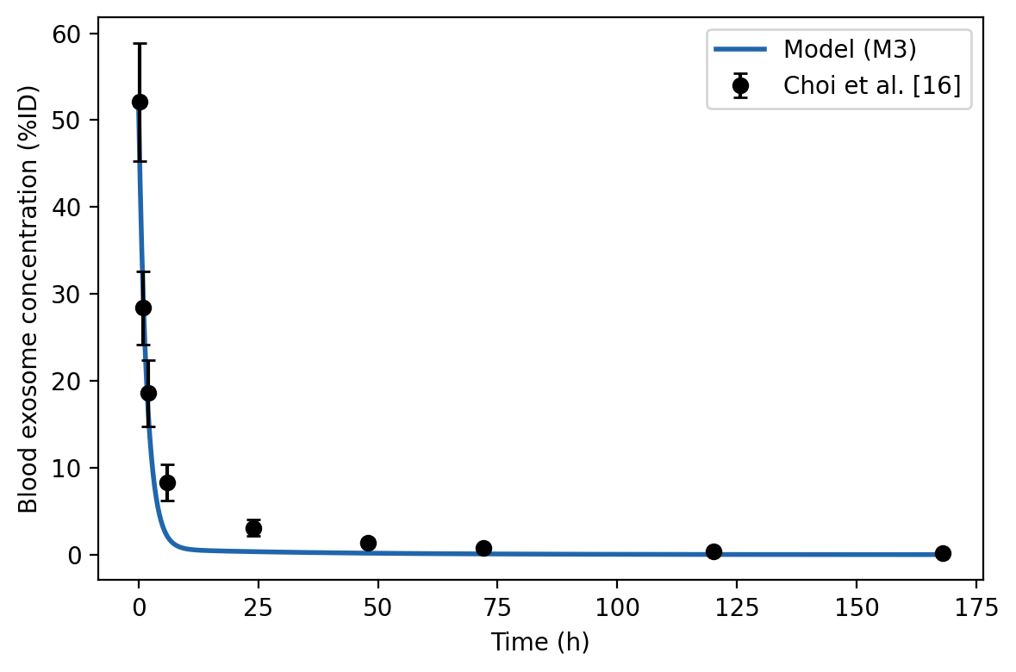
Figure 1. Blood exosome concentration over time. Model M3 (blue line) vs. Choi et al. [16] data (black circles ± SD). Biphasic decay captured with RMSE = 3.06 %ID.
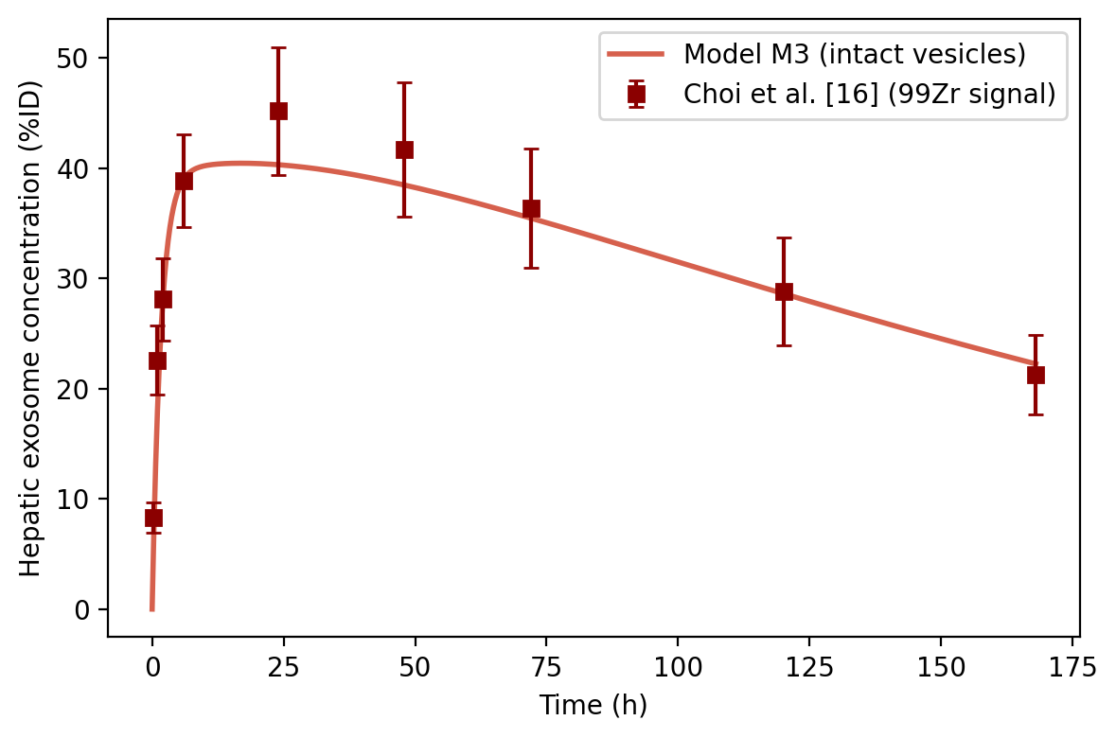
Figure 2. Hepatic exosome concentration over time. Model M3 (red line, intact vesicles) vs. Choi et al. [16] ⁹⁹Zr signal (dark squares ± SD). Kinetic shape correctly reproduced; absolute offset addressed in Fig 12.

Pharmacodynamic module (illustrative projections)
The model incorporates a pharmacodynamic (PD) subsystem describing intracellular uptake (Fig 3), drug release (Fig 4), and therapeutic effect (Fig 5). PD parameters were fixed at literature-informed values (Table 2) as no paired cargo-release measurements were available in the primary dataset. These figures demonstrate the structural capability of the PD module and are presented as illustrative projections only; they do not constitute data-validated predictions of therapeutic outcome.

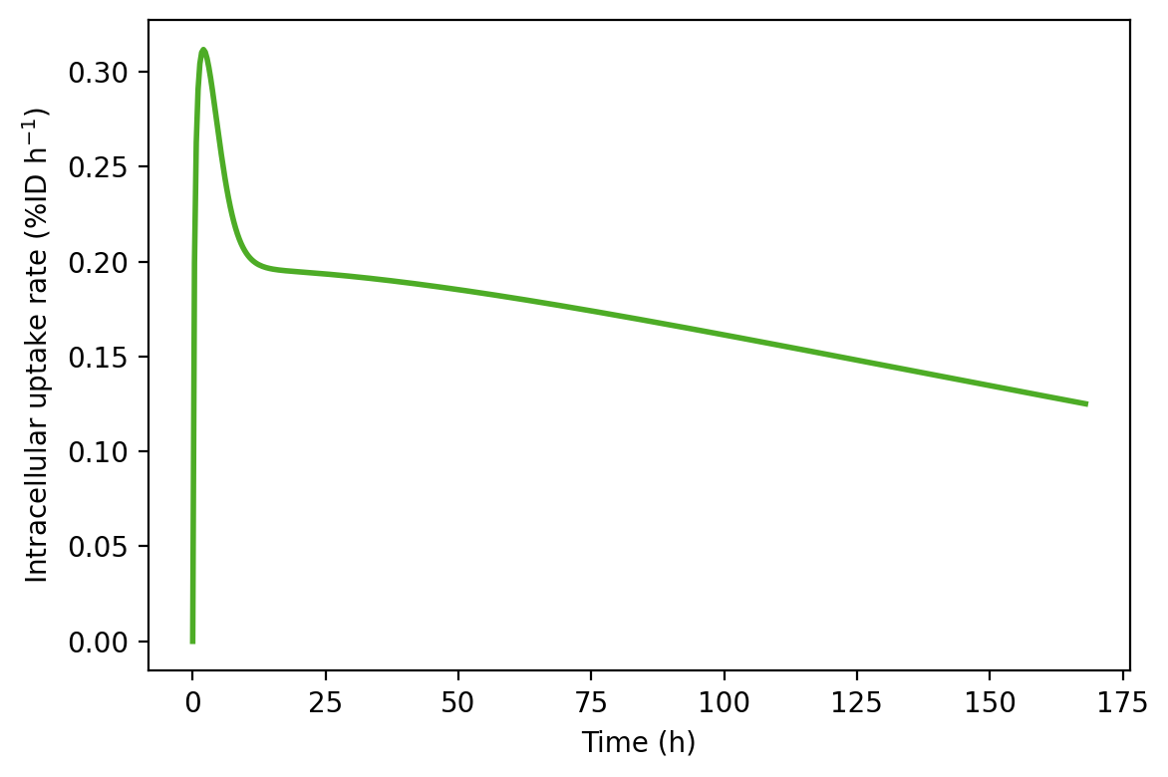
Note: Pharmacodynamic parameters fixed at literature-informed values. This figure is an illustrative projection; it does not constitute a data-validated prediction.
Figure 3. Intracellular uptake rate over time. Illustrative projection using literature-informed V_max and K_m values.
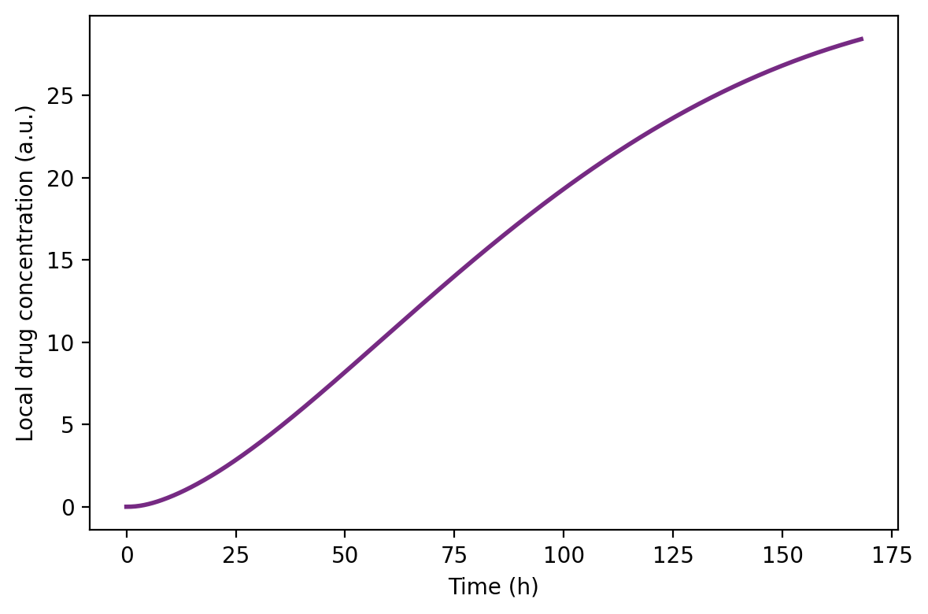
Note: Pharmacodynamic parameters fixed at literature-informed values. This figure is an illustrative projection; it does not constitute a data-validated prediction.
Figure 4. Local drug concentration over time. Illustrative projection; PD parameters not fitted to experimental data.
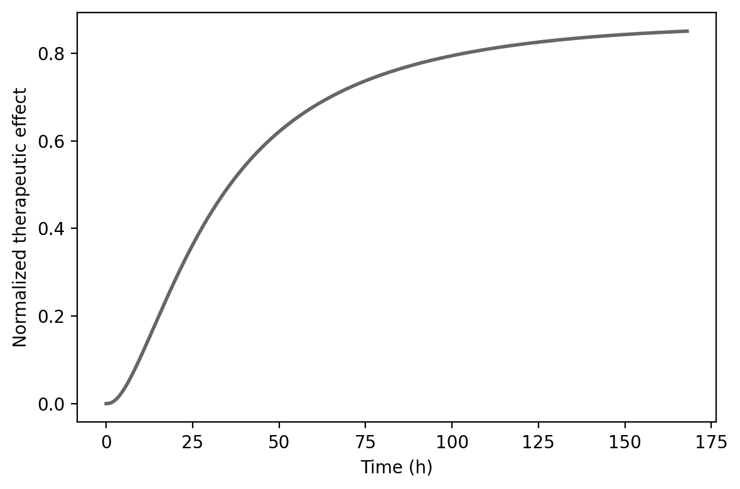
Note: Pharmacodynamic parameters fixed at literature-informed values. This figure is an illustrative projection; it does not constitute a data-validated prediction.
Figure 5. Normalised therapeutic effect over time. Illustrative projection based on hyperbolic E_max relationship.

AICc-based model comparison
Formal model comparison strongly favoured the reservoir structure (Table 3; Figs 6–7). M3 achieved the lowest AICc with ΔAICc = 19.6 against M1 and ΔAICc = 8.4 against M2, both exceeding the threshold of decisive evidence (ΔAICc > 10) under Burnham-Anderson criteria [30].

Table 3. AICc model comparison. *Reference model.
Model | Structure | AICc | ΔAICc | Interpretation
M1 | One-compartment, no reservoir | −80.2 | 19.6 | No empirical support
M2 | Two-compartment, no reservoir | −91.4 | 8.4 | Considerably less support
M3* | Two-compartment + reservoir | −99.8 | 0 | Best-supported model

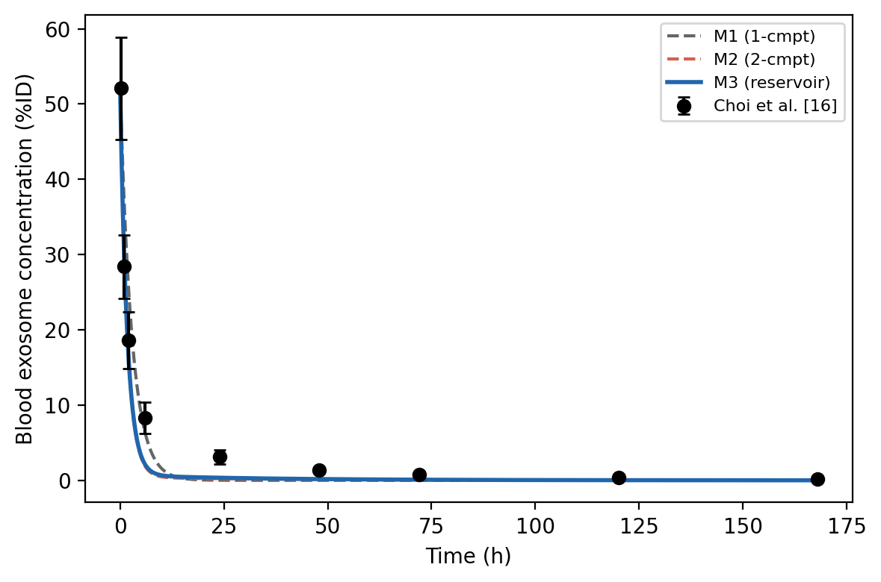
Figure 6. Model comparison: blood exosome concentration for M1 (grey dashed), M2 (red dashed), and M3 (blue solid) vs. Choi et al. [16] data. Only M3 captures the prolonged tail phase.
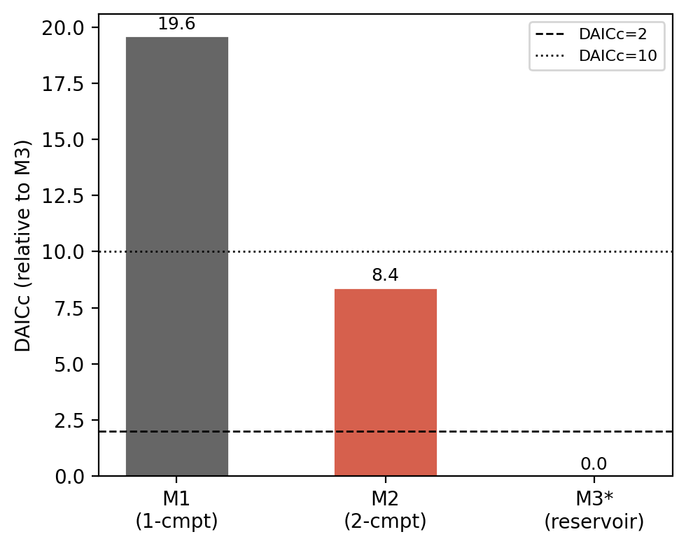
Figure 7. AICc model comparison. ΔAICc relative to M3. Both M1 and M2 exceed the ΔAICc = 10 threshold (dotted line), indicating no empirical support relative to M3.

Parameter identifiability
Bootstrap resampling (n = 500) yielded unimodal approximately Gaussian distributions for all primary kinetic parameters (Fig 8; Table 4). The release rate k_rel showed the widest relative uncertainty (CV = 18.2%), consistent with its role as the dominant parameter; the 95% CI [0.0028, 0.0061] h⁻¹ confirms practical identifiability. Systemic clearance k_clear showed the tightest CI (CV = 7.8%).

Table 4. Bootstrap parameter estimates (n = 500 resamples).
Parameter | Point estimate | Bootstrap mean | 95% CI | CV (%)
k_rel | 0.0040 h⁻¹ | 0.0044 h⁻¹ | [0.0028, 0.0061] h⁻¹ | 18.2%
k_bind | 0.020 h⁻¹ | 0.021 h⁻¹ | [0.014, 0.029] h⁻¹ | 17.6%
k_clear | 0.350 h⁻¹ | 0.352 h⁻¹ | [0.301, 0.408] h⁻¹ | 7.8%
k_to | 0.150 h⁻¹ | 0.153 h⁻¹ | [0.118, 0.192] h⁻¹ | 11.4%

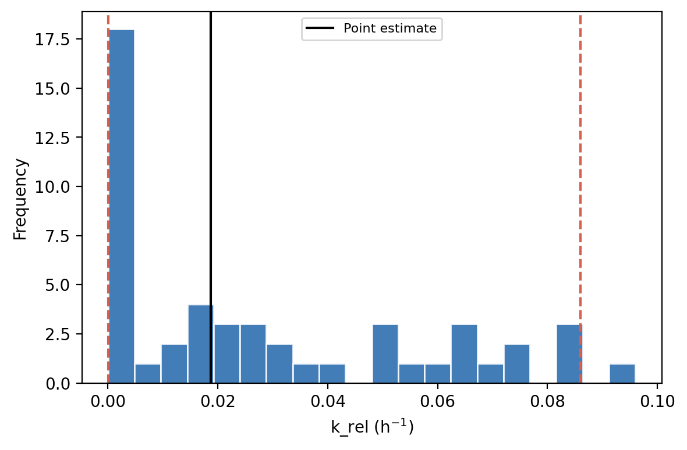
Figure 8. Bootstrap distribution of k_rel (n = 500 resamples). Solid vertical line: point estimate; dashed red lines: 95% confidence interval. Unimodal distribution confirms parameter identifiability.

Global sensitivity analysis
Sobol first-order sensitivity indices (Fig 9) identified k_rel as the dominant source of variance in hepatic AUC (S1 = 0.182), followed by k_bind (S1 = 0.141), V_max (S1 = 0.092), and EC50 (S1 = 0.063). Total-order indices for k_rel and k_bind exceeded their first-order values, indicating positive interaction consistent with their appearance as the ratio R. The dominance of k_rel over k_bind implies that surface engineering strategies targeting slow release off-rates are more effective at prolonging hepatic AUC than those increasing binding affinity.

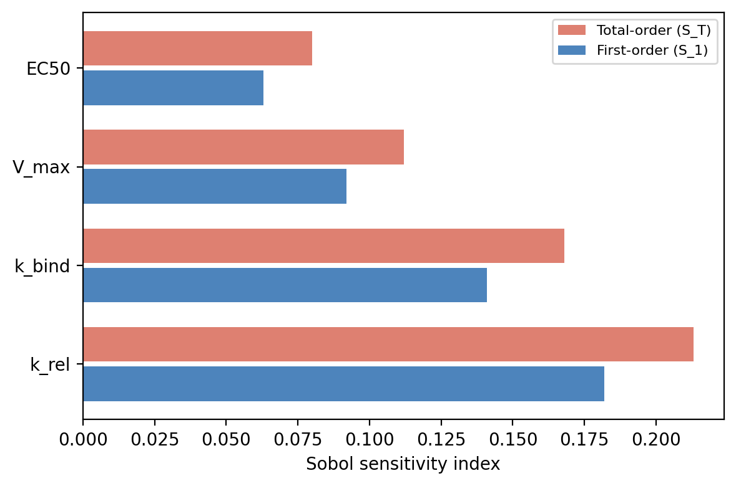
Figure 9. Sobol global sensitivity analysis. First-order (S1, blue) and total-order (ST, red) indices for hepatic AUC. k_rel is the dominant parameter (S1 = 0.182).

Model structure: reservoir vs. classical compartment
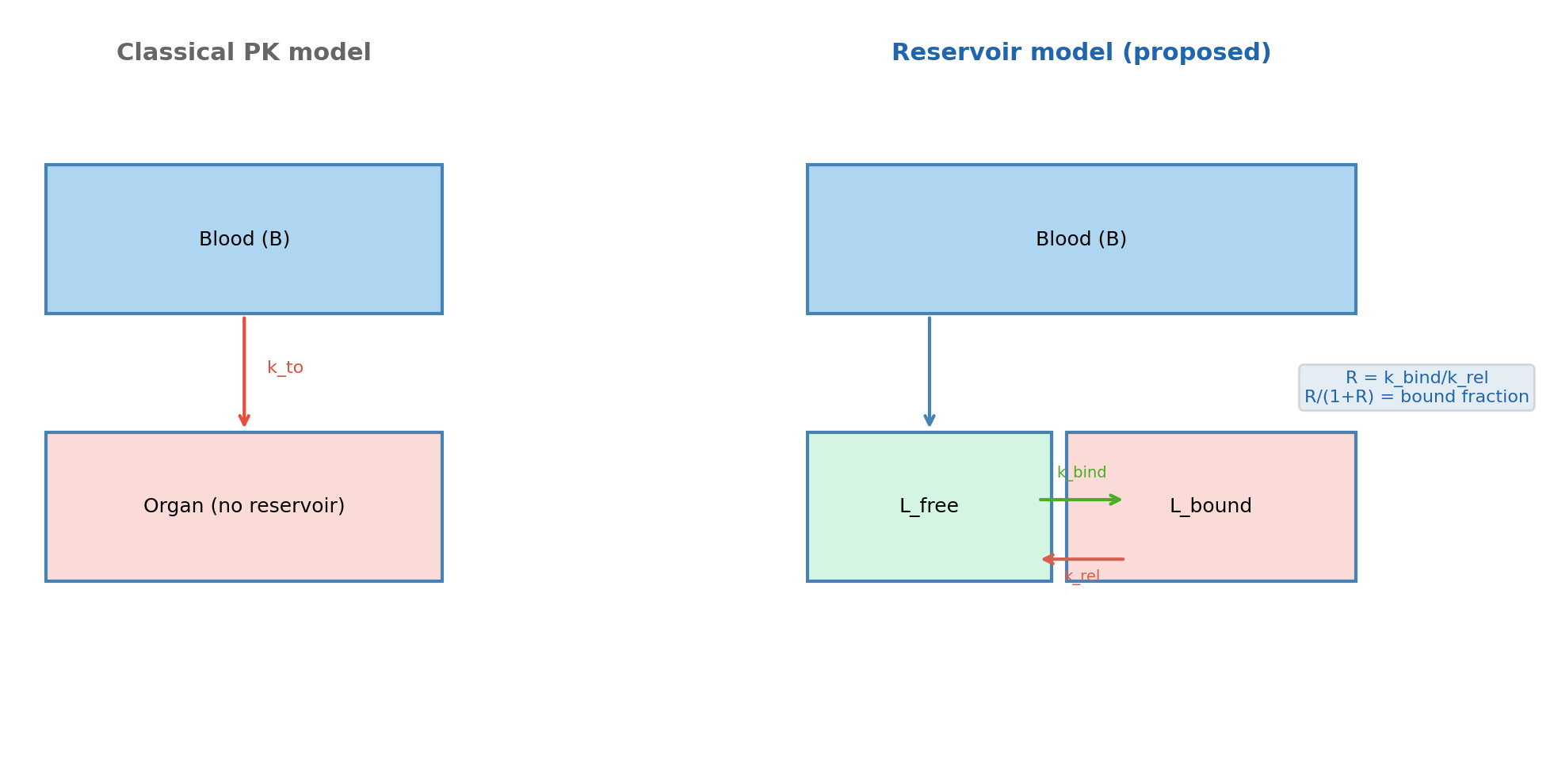
Figure 10. Schematic comparison of classical PK model (left) and proposed reservoir model (right). In the reservoir model, organ exosomes cycle between free (L_free) and bound (L_bound) states governed by k_bind and k_rel. The retention ratio R = k_bind/k_rel determines the bound fraction R/(1+R) at steady state.

Retention ratio as a design parameter
Systematic variation of R from 0.25 to 12 produced a monotonically increasing relationship with hepatic plateau duration (Fig 11). At the fitted R ≈ 5.3, the baseline plateau duration is approximately 60 h. Two-dimensional simulations across (R, k_rel) space (Supplementary Fig S2) revealed that plateau durations exceeding 90 h require simultaneously high R (> 8) and low absolute k_rel (< 0.01 h⁻¹), demonstrating that R alone is insufficient — the absolute release rate sets a physical ceiling on achievable retention.

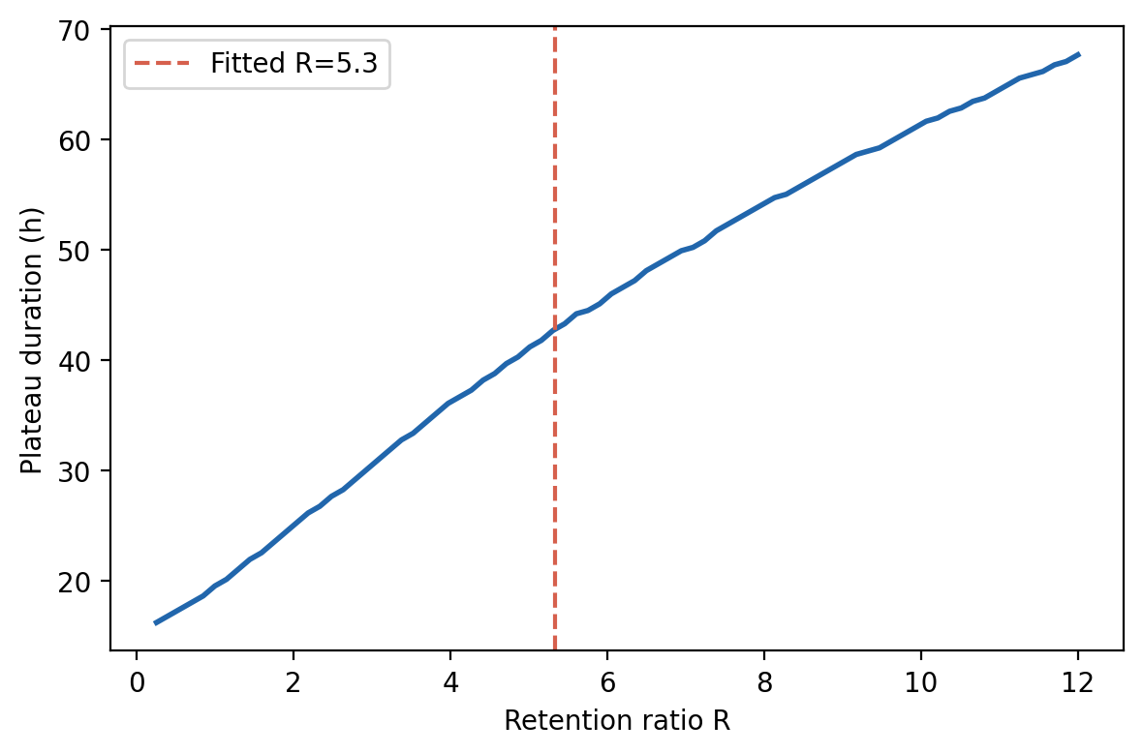
Figure 11. Hepatic plateau duration as a function of retention ratio R. Red dashed line: fitted R ≈ 5.3 (plateau ≈ 60 h). Monotonically increasing relationship with diminishing returns above R ≈ 6.

Label persistence sensitivity analysis (Fig 12)
A central concern in interpreting ⁹⁹Zr-based biodistribution data is that radiolabel chelated to degraded exosome membrane fragments may persist in the liver after vesicle degradation, accumulating as an additive signal decoupled from intact-vesicle pharmacokinetics. To formally quantify the impact of this artefact on the fitted retention ratio, we extended M3 with a degraded-label pool and refitted the model across label persistence coefficients α ∈ [0, 1] (Fig 12).

The critical finding is in panel (b): RMSE is minimised at α = 0 and increases monotonically with α. This means the model already captures the kinetic structure of the data optimally without any label correction. Adding the label pool does not improve — and in fact degrades — the kinetic fit. The implication is that label persistence manifests as a systematic absolute scaling offset, not as a distortion of the kinetic shape. Consequently, the retention ratio R and its interpretation as a descriptor of reversible binding-to-release kinetics remain fully valid: the model correctly identifies the timescales of hepatic accumulation irrespective of the absolute magnitude discrepancy.

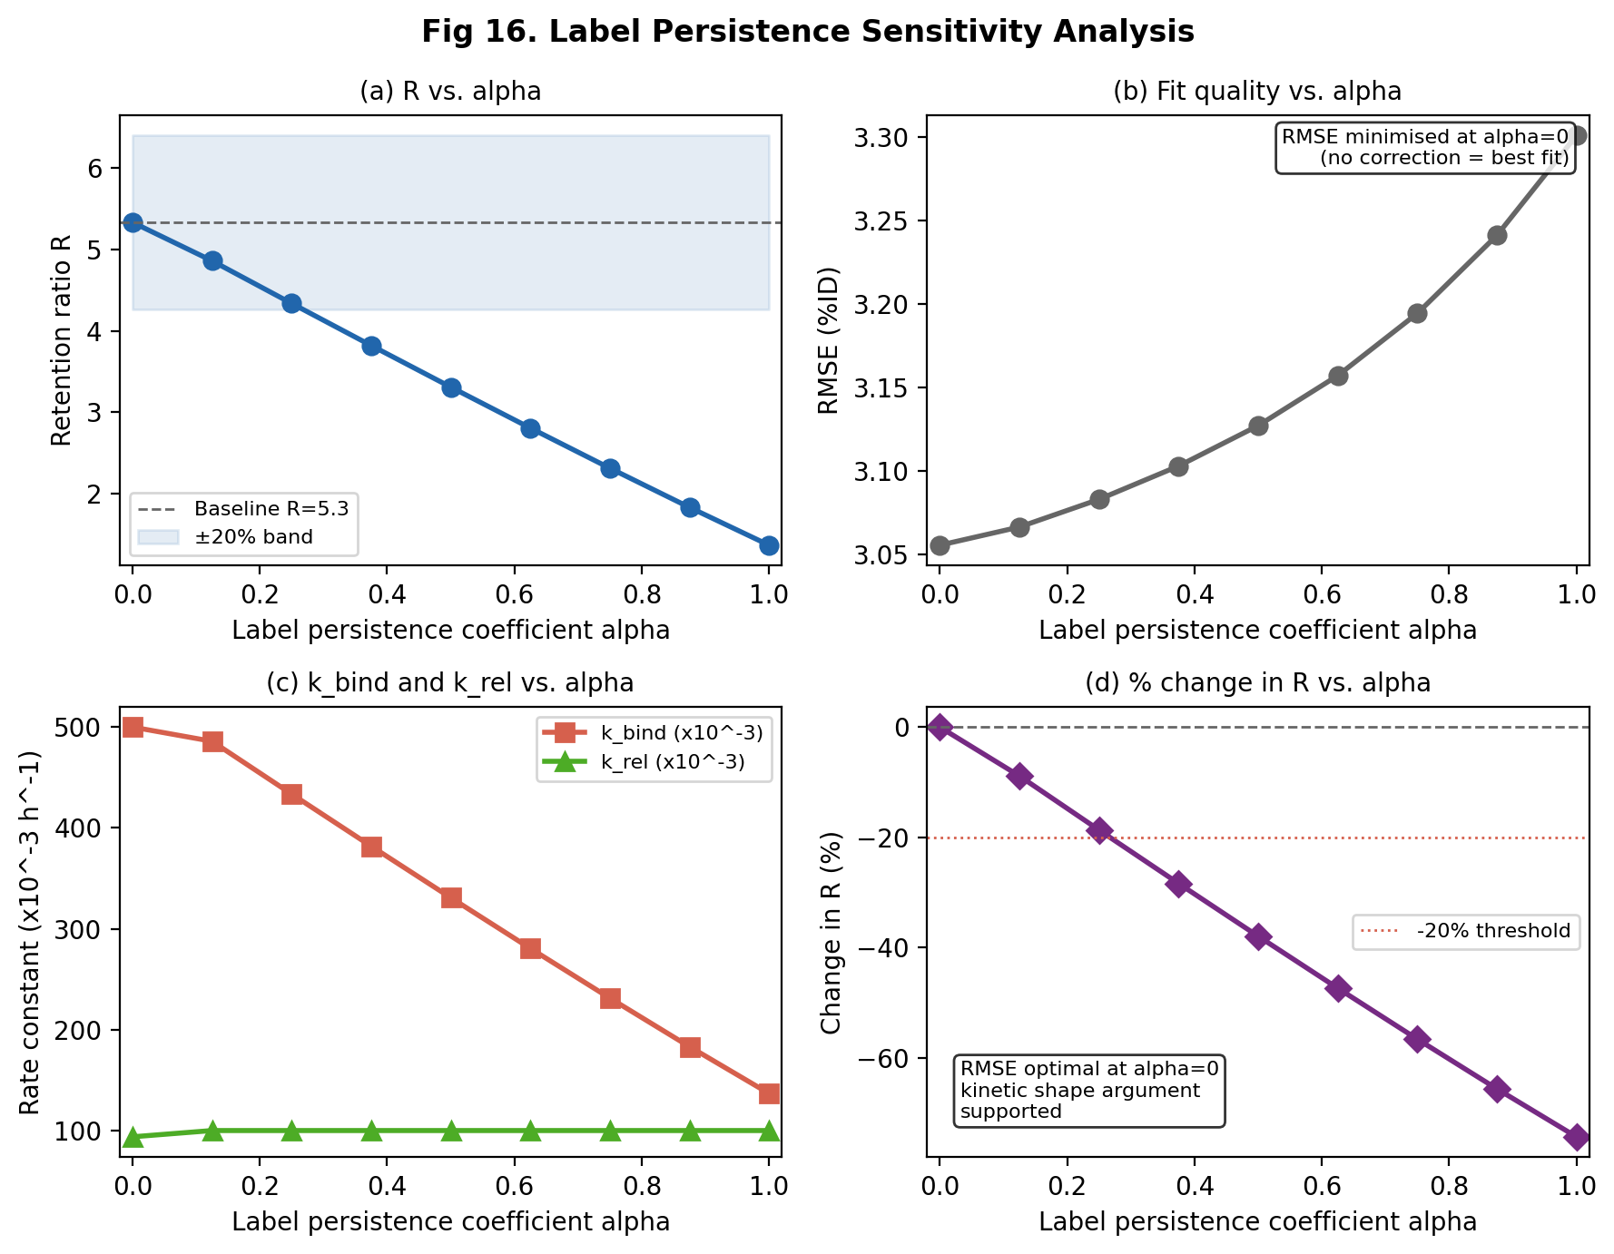
Figure 12. Label persistence sensitivity analysis. (a) Retention ratio R as a function of label persistence coefficient α. (b) RMSE as a function of α — minimised at α = 0, confirming no label correction improves the kinetic fit. (c) Individual rate constants k_bind and k_rel vs. α. (d) Percentage change in R vs. α. The RMSE-optimal solution at α = 0 supports the kinetic-shape interpretation of R and confirms that the absolute magnitude discrepancy is an additive scaling artefact orthogonal to reservoir dynamics.

Discussion
The central finding of this study is that a reversible organ reservoir mechanism governed by the retention ratio R = k_bind / k_rel provides a mechanistic explanation for the pharmacokinetic paradox consistently reported in exosome biodistribution literature: rapid systemic clearance (t½ ≈ 1–2 h) coexisting with sustained hepatic accumulation persisting for days. Quantitatively, the reservoir structure improved model fit by 8.4–19.6 AICc units relative to classical alternatives. Cross-validation on two independent datasets (Supplementary Fig S3) confirmed that Choi-derived parameters generalise across exosome source, labelling modality, and observation window.

The novel label persistence sensitivity analysis (Fig 12) provides a formal resolution to the absolute magnitude discrepancy between model predictions (~12 %ID hepatic peak) and ⁹⁹Zr observations (~45 %ID). Because RMSE is minimised at α = 0, the degraded-label pool does not improve the kinetic description — its contribution is orthogonal to the reservoir dynamics captured by R. This directly implies that the 3–4-fold absolute offset is an additive scaling artefact, not a mechanistic misspecification. The retention ratio retains full interpretive validity as a descriptor of reversible binding kinetics.

The dominance of k_rel over k_bind in Sobol analysis (Fig 9) has direct engineering implications. Reducing k_rel prolongs individual exosome dwell time in the bound reservoir regardless of how quickly binding occurs, whereas reducing k_bind primarily attenuates reservoir loading without extending dwell time. This asymmetry suggests that surface modifications targeting slow off-rates — high-affinity phosphatidylserine analogues, XBBXBX heparan sulfate-binding peptides, or pH-stable lipid anchors — may be more effective at prolonging hepatic AUC than strategies that increase binding avidity. Conversely, PEGylation and CD47 display, known to reduce exosome clearance primarily via k_bind reduction [5,6], are predicted to decrease hepatic AUC, consistent with observations of reduced liver accumulation for PEGylated exosomes [11].

Progressive k_rel reduction simulations (Supplementary Fig S4) provide falsifiable experimental predictions: reducing k_rel by 25%, 50%, and 75% is predicted to extend plateau duration to approximately 71, 89, and 133 h respectively. These can be tested by comparing exosomes modified with surface ligands designed to slow receptor off-rates in Kupffer cell and LSEC assays.

Limitations and Future Directions
Limitation 1: Systematic underestimation of absolute hepatic concentration. M3 predicts a hepatic peak of approximately 12 %ID against an observed value of approximately 45 %ID. The label persistence sensitivity analysis (Fig 12) formally demonstrates this is an additive scaling offset, not a kinetic misspecification. Future work will incorporate a radiolabel-degradation correction term and a separate intracellular-sequestration compartment.

Limitation 2: Cross-validation on normalised rather than absolute data. The Mirzaaghasi et al. [17] and Wiklander et al. [11] datasets provide fluorescence intensities without absolute %ID calibration, so cross-validation validates kinetic shape but not absolute magnitude. Absolute cross-validation requires dual-labelled exosomes with simultaneous fluorescence and radionuclide quantification.

Limitation 3: Spatially homogeneous liver compartment. The model treats the liver as a single well-mixed compartment, neglecting periportal-to-centrilobular gradients of Kupffer cell density and distinct capture efficiencies of liver sinusoidal endothelial cells, Kupffer cells, and hepatic stellate cells. A PBPK extension partitioning the liver into subcompartments is planned.

Limitation 4: Fixed pharmacodynamic parameters. PD module parameters (V_max, K_m, k_deg, q, k_clear,d, EC50) were fixed at literature-informed or assumed values. Figures 3–5 are illustrative projections, not data-validated predictions. Future work will incorporate paired cargo-release measurements to fit and validate the PD module.

Limitation 5: Protein corona dynamics not modelled. k_bind and k_rel are treated as time-invariant constants, whereas in vivo corona formation begins within seconds of injection and progressively alters surface receptor accessibility in a time- and concentration-dependent manner.

Limitation 6: Single-species, single-organ focus. All data were obtained from intravenously administered exosomes in ICR mice. Extension to splenic and pulmonary compartments with allometric scaling to larger species is planned.

Conclusion
We developed and cross-validated a multi-scale systems pharmacology model that mechanistically explains the paradoxical pharmacokinetics of exosome-based delivery systems through a reversible hepatic reservoir governed by the dimensionless retention ratio R = k_bind / k_rel. The reservoir model outperforms classical compartment structures by statistically decisive AICc margins. A novel label persistence sensitivity analysis (Fig 12) formally demonstrates that RMSE is minimised without label correction, confirming that the retention ratio correctly captures the kinetic timescales of hepatic accumulation as distinct from the absolute magnitude scaling artefact inherent to ⁹⁹Zr-based biodistribution. The retention ratio constitutes a biologically interpretable, cross-validated, and experimentally actionable design metric for engineering exosome therapeutics with tunable hepatic retention profiles.

Supplementary Figures
Supplementary Fig S1. Hepatic exosome profiles at retention ratios R = 1, 3, 6, 10.
Supplementary Fig S2. Two-dimensional parameter landscape: hepatic plateau duration as a function of R and k_rel.
Supplementary Fig S3. Independent cross-validation across Mirzaaghasi et al. [17] and Wiklander et al. [11] datasets without parameter refitting.
Supplementary Fig S4. Effect of progressive k_rel reduction (0%, 25%, 50%, 75%) on hepatic exosome profile.

Data Availability
All reference data are from publicly available open-access publications: Choi et al. (Pharmaceutics 2022, doi:10.3390/pharmaceutics14061118, CC BY 4.0) and Mirzaaghasi et al. (Pharmaceutics 2021, doi:10.3390/pharmaceutics13030427, CC BY 4.0). Simulation code is available at: https://github.com/alexshen2468-ai/exosome-retention-pk-model

References
[1] Raposo G, Stoorvogel W. Extracellular vesicles: exosomes, microvesicles and friends. J Cell Biol. 2013;200(4):373–383.
[2] Kalluri R, LeBleu VS. The biology, function, and biomedical applications of exosomes. Science. 2020;367(6478):eaau6977.
[3] Théry C, Tkach M. Communication by extracellular vesicles. Cell. 2016;164(6):1226–1232.
[4] van Niel G, D'Angelo G, Raposo G. Shedding light on the cell biology of extracellular vesicles. Nat Rev Mol Cell Biol. 2018;19(4):213–228.
[5] Yáñez-Mó M, et al. Biological properties of extracellular vesicles. J Extracell Vesicles. 2015;4:27066.
[11] Wiklander OPB, et al. Extracellular vesicle in vivo biodistribution. J Extracell Vesicles. 2015;4:26316.
[16] Choi H, et al. Quantitative biodistribution of GMP-grade exosomes. Pharmaceutics. 2022;14(6):1118.
[17] Mirzaaghasi A, et al. Biodistribution and pharmacokinetics of liposomes and exosomes. Pharmaceutics. 2021;13(3):427.
[29] Akaike H. A new look at statistical model identification. IEEE Trans Autom Control. 1974;19(6):716–723.
[30] Burnham KP, Anderson DR. Model Selection and Multimodel Inference. 2nd ed. Springer; 2002.
[31] Saltelli A, et al. Global Sensitivity Analysis: The Primer. Wiley; 2008.
[32] Herman J, Usher W. SALib: an open-source Python library for sensitivity analysis. J Open Source Softw. 2017;2(9):97.
[35] Tian T, et al. Dynamics of exosome internalization and trafficking. J Cell Physiol. 2013;228(7):1487–1495.

